**IDEATION PHASE**

Problem Statement

|  |  |
| --- | --- |
| Date | 28/02/2025 |
| Team ID |  |
| Project Name | Eye Disease Detection Using Deep Learning |
| Maximum Marks |  |

**Customer Problem Statement :**

Millions of people worldwide suffer from eye diseases that, if left undiagnosed or untreated, can lead to severe vision impairment or blindness. Traditional diagnostic methods depend on manual examination by ophthalmologists, which can be time-consuming, inconsistent, and inaccessible to many individuals, particularly in remote or underserved areas. The lack of early detection and misdiagnosis can result in irreversible vision loss, significantly impacting the quality of life of affected individuals.

There is a critical need for an automated, accurate, and scalable solution that can aid in the early detection and classification of eye diseases. Patients require a reliable and accessible system that can quickly diagnose conditions such as Cataract, Diabetic Retinopathy, and Glaucoma based on retinal images. Ophthalmologists and healthcare providers also need a tool that can enhance diagnostic accuracy, reduce workload, and optimize patient care.

This project addresses these challenges by leveraging deep learning and transfer learning techniques to develop an AI-powered system capable of efficiently identifying and categorizing eye diseases. By providing a fast, precise, and cost-effective diagnostic solution, this project aims to improve early detection rates, facilitate timely medical intervention, and enhance overall eye health outcomes.

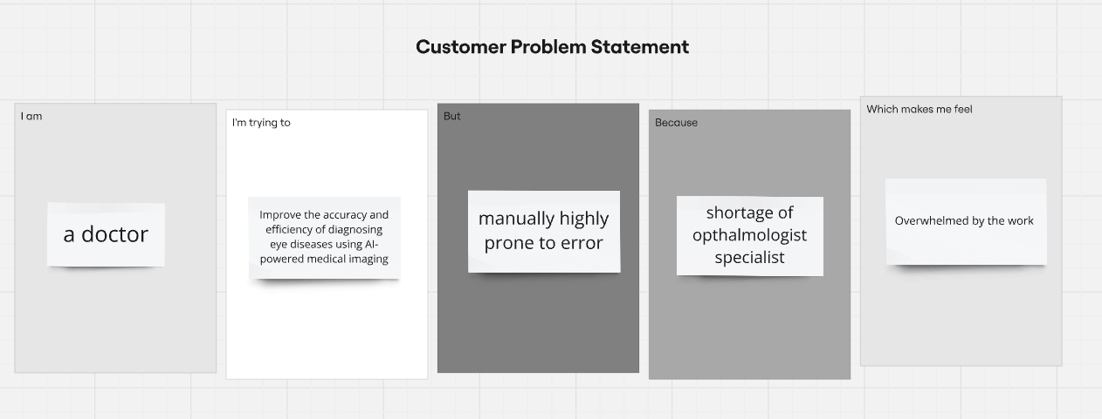

|  |  |  |  |  |  |
| --- | --- | --- | --- | --- | --- |
| **Problem Statement (PS)** | **I am (Customer)** | **I’m trying to** | **But** | **Because** | **Which makes me feel** |
| PS-1 | Doctor | Improve the efficiency of diagnosing eye diseases using AI – driven solution | Manually it is time consuming and prone to error | Shortage of doctors | Overwhelmed by the work |
| PS-2 | Optometrist | Want the solution to detect eye disease using an AI driven solution | But I can’t do that as not a specialist to read images | Only specialist can perform such thing | Concerned about missing critical diagnoses, pressured to provide accurate results quickly which made me feel underwhelmed as an eye specialist can do only. |